(Approx. 1358 words)
Ripping Audio CDs Using MediaMonkey 5
By Tom Burt, Vice President, Sun City Summerlin Computer Club
https://www.scscc.club
tomburt89134 (at) cox.net
I first wrote about the MediaMonkey 4 media player/manager tool in October 2019. At that time, I was interested in MediaMonkey as a replacement for Apple’s iTunes media player. I found it to be very capable, plus it had a free version that did everything I was looking for.

Recently the MediaMonkey developers released an upgrade to version 5. Also, for Father’s Day, 2021, one of my sons sent me a box set of the Complete Albums Collection of Simon & Garfunkel. I decided to “rip” all 12 CDs to convert them to music files in my music collection. I decided to convert all the CD tracks to the open-source FLAC (Free Lossless Audio Codec) format to achieve maximum sound fidelity. The output FLAC files are fairly large compared to the MP3 format but should sound identical to the original CD tracks. iTunes has no support for the FLAC format, so I again turned to MediaMonkey.

First, for those who may have missed my October 2019 column, here’s a screenshot of the MediaMonkey 5 main screen.

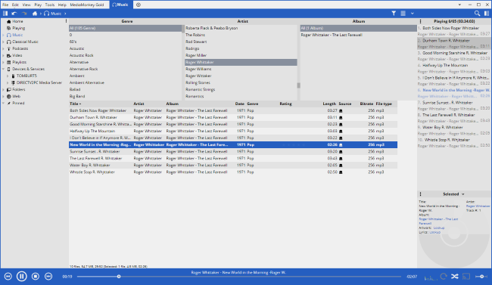

MediaMonkey 5 Main Screen

MediaMonkey’s main screen (Music View) can be configured to be very similar to that in iTunes. It features a 3-column hierarchical browser (Genre, Artist, Album) that can filter a list of song titles displayed in a table pane below the browser columns. Along the bottom are controls for playing, pausing, skipping, a progress bar with time played and time remaining, and some buttons for special features like shuffle and enabling the equalizer. The left-hand pane allows choosing between major views, including Playlists. The right-hand pane displays a list of the songs queued up for playing. At the lower right is a small pane with detailed information about the current song that’s playing.

Along the top are a menu bar and a toolbar that together provide a rich set of functions for setting options, importing tracks into the song library, building playlists, ripping CDs, burning discs, converting file formats, and synching to external devices.

Importing Existing Music Files

When first launched, MediaMonkey offered to import your music files into its music library. You can specify which folder(s) it should scan. MediaMonkey reads each music file in the designated tree of folders and extracts the ID1 and ID2 tag information into fields in its library database. It imported my 6000 file (22 GB) collection in about five minutes. Each record in the library database points back to the actual path\filename of the music file.

You can use the File menu to add additional music files to the library. You can also have MediaMonkey rescan previously indexed folders to update the music index. If you used another program like iTunes to update tag information, this might come into play.

Playlists

A playlist is a named ordered list of music files, typically a subset of your entire collection. Examples might be “My top 100” or “Favorite Instrumentals” or “Christmas Music” or “Party Mix.” In MediaMonkey, you can start a new playlist by right-clicking on the Playlists item in the left-hand (View) pane and then clicking New Playlist. A small dialog will open asking for the name of the new playlist. Type in a name and then click OK. Your new playlist will appear in the listing under the Playlists item.

To add tracks to a playlist, go to the Music view, leaving the Playlists item open to make the individual playlists visible. Select one or more music files, and then drag the selection onto the name of your new playlist. Repeat for all the music files you want added to the playlist.

Under the Playlists, view item, click to select your new playlist, and all the song files it contains will be shown in the file list pane. To play a music file, double-click it. You can also turn on the shuffle mode to randomly play the tracks in your playlist. To change the play order, select any track in the main list pane and drag it up or down in the list.

You can right-click on a playlist and choose “Send to,” which offers various options, including “Burn to CD/DVD” and “Copy to Folder.” Both will copy the music files in the playlist to the specified target. For example, “Copy to Folder” can be used to copy a playlist to a flash drive for playing in your car’s entertainment center or taking to a party.

Editing Music File Information

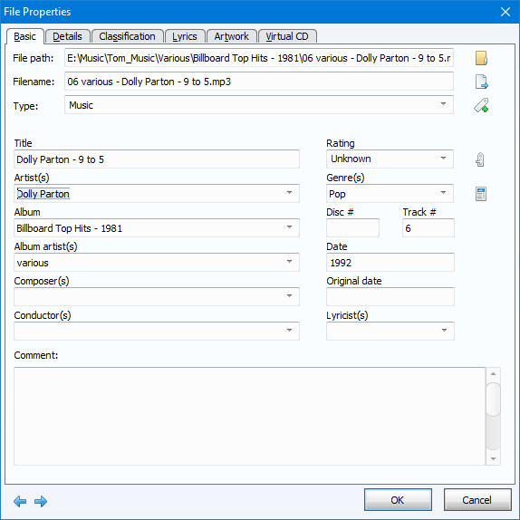
To modify the tag information for a music file, right-click it in the file list pane and select Properties. An editor dialog will display with fields that you can edit. Change the field values to suit and click OK to save the results.

You can also select multiple files, right-click the selection and choose Properties. In this mode, you can edit properties common to the selected set.

Ripping Audio CDs

A common way to add to your digital music collection is to convert audio CDs you own or borrow to individual digital music files on your PC’s hard drive. This process is known as ripping. MediaMonkey makes ripping very easy. First, insert an audio CD into your PC’s CD/DVD drive with MediaMonkey running. Then, in MediaMonkey, click your CD/DVD drive in the left-hand (view) pane and click the Rip Audio CD button in the toolbar. A CD Ripping dialog (see below) will appear, listing the tracks with the song titles, the folder to which the ripped music files will be written, and the file name layout.

The track information displayed is looked up in the Internet FreeDB database, a comprehensive listing of every commercial audio CD produced by the music industry. Take a few moments to configure the various settings. Click the Configure button to set the destination folder into which the ripped music files will be copied and the format for the file names. I like the folder hierarchy to be Album Artist > Album Name. I like the output file name to be Artist – Song name. The file extension depends on the output format you choose, such as MP3, FLAC, or OGG.

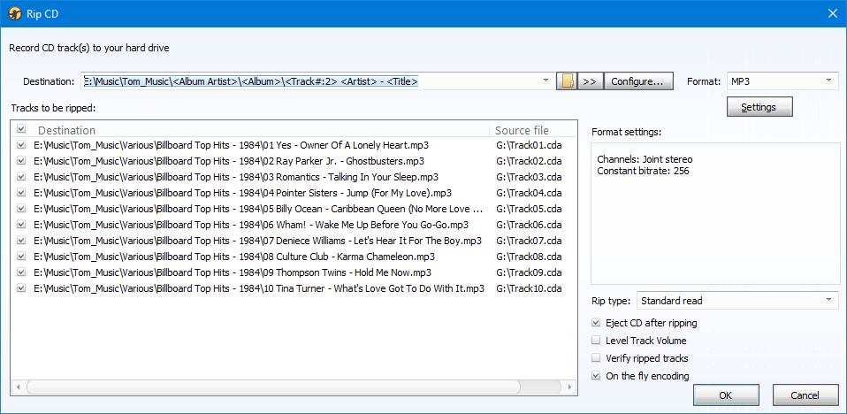

MediaMonkey Rip Audio CD Dialog

Also, click the Settings button to choose the sampling bit rate and other values for the selected format. Usually, I choose MP3 format, Constant Bit Rate, 256 kilobits. This is the same as what most commercial digital music is now encoded to. However, I chose the FLAC format for my Simon & Garfunkel project and left other Settings values at their defaults. Once set, your settings will be remembered for future CD rips.

Finally, click the OK button, and MediaMonkey will read each audio track from the CD and convert it to a music file in the selected format, stored in the specified folder with the specified file name. For each ripped file, the music library database will have a record added pointing to the song file, with all the tag information (Artist, Album, Genre, Title, Year, Play Time, etc.) Typically, it takes 2 to 3 minutes to rip an entire audio CD.

Results

The FLAC files ripped by MediaMonkey sounded extremely good when played by MediaMonkey and by Windows 10’s built-in Groove music player. As an experiment, I had also ripped one album to MP3 format using the maximum sample rate of 320 Kbits/sec; I wanted to compare the sound quality and file sizes between FLAC and MP3-320.

As an example, from Simon & Garfunkel’s “Concert in Central Park” album, for the track “Late in the Evening” (time 4:07), I got the following file sizes (including a prior rip to MP3 at 256 Kbits sampling):

FLAC: 25.9 Mbytes MP3-320: 9.7 Mbytes MP3-256: 7.8 Mbytes

In MediaMonkey, the FLAC file sounded sharper and brighter than the MP3-320, but the difference was relatively small. I also tried playing the MP3-320 track in iTunes, but it didn’t sound clear. So, it appears MediaMonkey’s music player is better at reproducing sound than iTunes.

That’s all I have space for. However, MediaMonkey seems to be a great alternative to iTunes, and it’s free. Give it a try!

